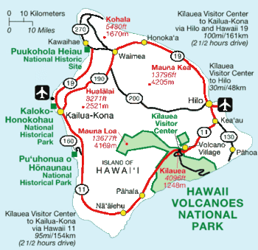Directions from Kailua-Kona Airport to Hawi - (approximately 1 hour drive)
- Once you leave the airport car rental, turn left onto the main airport road (Keahole St/Keahole Airport Rd). Travel until you reach the stop light at the main highway (Queen Ka’ahumanu Hwy - Route #19).
- Turn left heading north on Rt. 19 (aka Queen Ka’ahumanu Hwy)
- Drive until you come to the end of the road and a stop sign (approx 26 miles).
- Turn left onto HI-270/Kawaihae-Mahukona Rd.
- In about 2 miles you will enter the small harbor town of Kawaihae. The road bears to the right.
- Travel approximately 18 miles toward the old Hawaiian town of Hawi.
- As you drive along the starkly beautiful Kohala Coast Road 270, with whales breeching and spouting in winter months, you'll pass signs for three State Parks ~ Lapakahi, Mahukona and Kapaa
- From Mahukona (exactly 3.9 miles), and directly past the left-hand turn-off to Puakea Bay Estates, you will turn left onto Old Coast Guard Rd, Watch for the second sign. (There is also one for Puakea Bay)
- Turn immediately right (no street name). Go to the end of the short road.
- Turn left into the driveway, and park

